CTR QUIZ

------------------------------------------SOWMI 2015103611 ------------------------------------------

----------------------------------------- SWATHI 2015103050 -----------------------------------------

# **DATA STRUCTURES & ALGORITHMS QUIZ**

1.Which of the following operations is performed more efficiently by doubly linked list than by linear linked list?

(A) Deleting a node whose location is given

(B) Searching an unsorted list for a given item

(C) Inserting a node after the node with a given location

(D) Traversing the list to process each node

Answer: A)

2.The number of structurally different possible binary trees with 4 nodes is

(A) 14

(B) 12

(C) 336

(D) 168

Answer: A)

3.Consider the following C program:

#include

#define EOF -1

void push (int); /* push the argument on the stack */

int pop (void); /* pop the top of the stack */

void flagError ();

int main ()

{ int c, m, n, r;

while ((c = getchar ()) != EOF)

{ if (isdigit (c) )

push (c);

else if ((c == '+') || (c == '*'))

{ m = pop ();

n = pop ();

r = (c == '+') ? n + m : n*m;

push (r);

}

else if (c != ' ')

flagError ();

}

printf("% c", pop ());

}

What is the output of the program for the following input ?

5 2 * 3 3 2 + * +

(A) 15

(B) 25

(C) 30

(D) 150

Answer: B)

4.Consider a hash function that distributes keys uniformly. The hash table size is 20. After hashing of how many keys will the probability that any new key hashed collides with an existing one exceed 0.5.

(A) 5

(B) 6

(C) 7

(D) 10

Answer: D)

5.Which of following option is not correct regarding depth first searching?

(A) In a depth-first traversal of a graph G with V vertices, E edges are marked as tree edges. The number of connected components in G is (E – V).

(B) Depth-first search requires O(V^2) time if implemented with an adjacency matrix.

(C) Depth-first search requires O(V + E) time if implemented with adjacency lists

(D) None of these

Answer: A)

6.Which of the following cannot generate the full binary tree?

(A) Inorder and Preorder

(B) Inorder and Postorder

(C) Preorder and Postorder

(D) None of the above

Answer: D)

7.Let A be a square matrix of size n x n. Consider the following program. What is the expected output?

C = 100

for i = 1 to n do

for j = 1 to n do

{

Temp = A[i][j] + C

A[i][j] = A[j][i]

A[j][i] = Temp - C

}

for i = 1 to n do

for j = 1 to n do

Output(A[i][j]);

(A) The matrix A itself

(B) Transpose of matrix A

(C) Adding 100 to the upper diagonal elements and subtracting 100 from diagonal elements of A

(D) None of the above

Answer: A)

8.Which of the following traversal outputs the data in sorted order in a BST?

(A) Preorder

(B) Inorder

(C) Postorder

(D) Level order

Answer: B)

9.How many stacks are needed to implement a queue. Consider the situation where no other data structure like arrays, linked list is available to you.

(A) 1

(B) 2

(C) 3

(D) 4

Answer: B)

10.Which of the following statements is/are TRUE for an undirected graph?

P: Number of odd degree vertices is even

Q: Sum of degrees of all vertices is even

(A) P Only

(B) Q Only ii

(C) Both P and Q

(D) Neither P nor Q

Answer: C)

Algo:-

1.Which of the following is true about Huffman Coding.

(A) Huffman coding may become lossy in some cases

(B) Huffman Codes may not be optimal lossless codes in some cases

(C) In Huffman coding, no code is prefix of any other code.

(D) All of the above

Answer: C)

2.Which of the following algorithms is NOT w divide & conquer algorithm by nature?

(A) Euclidean algorithm to compute the greatest common divisor

(B) Heap Sort

(C) Cooley-Tukey fast Fourier transform

(D) Quick Sort

Answer: B)

3.What does the following function do?

int fun(int x, int y)

{

if (y == 0) return 0;

return (x + fun(x, y-1));

}

(A) x + y

(B) x + x*y

(C) x*y

(D) xy

Answer: C)

4.The number of distinct minimum spanning trees for the weighted graph below is

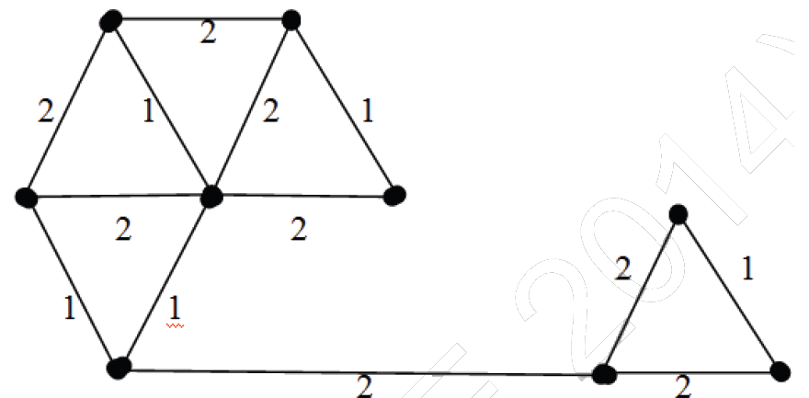

(A) 4

(B) 5

(C) 6

(D) 7

Answer: C)

5.What is the time complexity of the following recursive function:

int DoSomething (int n)

{

if (n <= 2)

return 1;

else

return (DoSomething (floor(sqrt(n))) + n);

}

(A) \theta(n)

(B) \theta(nlogn)

(C) \theta(logn)

(D) \theta(loglogn)

Answer: D)

6.Which of the following is true about NP-Complete and NP-Hard problems.

(A) If we want to prove that a problem X is NP-Hard, we take a known NP-Hard problem Y and reduce Y to X

(B) The first problem that was proved as NP-complete was the circuit satisfiability problem.

(C) NP-complete is a subset of NP Hard

(D) All of the above

(E) None of the above

Answer: D)

7 Which of the following is not a backtracking algorithm?

(A) Knight tour problem

(B) N queen problem

(C) Tower of hanoi

(D) M coloring problem

Answer: C)

8.What is the best sorting algorithm to use for the elements in array are more than 1 million in general?

(A) Merge sort.

(B) Bubble sort.

(C) Quick sort.

(D) Insertion sort.

Answer: C)

9.Which of the following is not a stable sorting algorithm in its typical implementation.

(A) Insertion Sort

(B) Merge Sort

(C) Quick Sort

(D) Bubble Sort

Answer: C)

10.Any decision tree that sorts n elements has height ________.

(A) Ω(lg n)

(B) Ω(n)

(C) Ω(n lg n)

(D) Ω(n2)

Answer: C)